**Project Planning Phase**

**Project Planning (Product Backlog, Sprint Planning, Stories, Story points)**

|  |  |
| --- | --- |
| Date | 22 October 2022 |
| Team ID | PNT2022TMID30308 |
| Project Name | Project – Real-time River Water Quality Monitoring and Control System |
| Maximum Marks | 8 Marks |

**Product Backlog, Sprint Schedule, and Estimation (4 Marks)**

| **Sprint** | **Functional Requirement (Epic)** | **User Story Number** | **User Story / Task** | **Story Points** | **Priority** | **Team Members** |
| --- | --- | --- | --- | --- | --- | --- |
| Sprint-1 | Sensor Data generated using Random in Python | USN-1 | River Water quality is monitored and the data been collected real time, which is simulated by the random function in Python and transferred to cloud | 2 | High | Dhinakar L |
| Sprint-2 | Setting up Cloud IoT Platform to collect the data and transfer to node Red | USN-2 | Collect the data from the python code and transfer it to the Application to enable real time monitoring | 1 | Medium | Srinivas Krishna S K |
| Sprint-3 | Web UI – Login, Registration, Dashboard | USN-3 | Create a platform to monitor the data. The user can Register and Login to access their real time data and alerts. The users have to Register themselves using their Mobile number to get Alerts about the data | 1 | Medium | Nandhagopal Vignesh A |
| Sprint-4 | Dashboard | USN-4 | The data from the monitoring system is processed and then displayed graphically for user understandability. | 2 | High | Haripriya S |
| Sprint-4 | Threshold Alert | USN-5 | Once the levels of proportions are crossing the threshold value, the alert is raised both in the Web UI and also through Fast SMS. | 2 | High | Srinivas Krishna S K |

**Project Tracker, Velocity & Burndown Chart: (4 Marks)**

| **Sprint** | **Total Story Points** | **Duration** | **Sprint Start Date** | **Sprint End Date (Planned)** | **Story Points Completed (as on Planned End Date)** | **Sprint Release Date (Actual)** |
| --- | --- | --- | --- | --- | --- | --- |
| Sprint-1 | 20 | 5 Days | 26 Oct 2022 | 30 Oct 2022 | 20 | 30 Oct 2022 |
| Sprint-2 | 20 | 5 Days | 31 Oct 2022 | 04 Nov 2022 | 20 | 04 Nov 2022 |
| Sprint-3 | 20 | 6 Days | 05 Nov 2022 | 10 Nov 2022 | 20 | 10 Nov 2022 |
| Sprint-4 | 20 | 5 Days | 11 Nov 2022 | 15 Nov 2022 | 20 | 15 Nov 2022 |

**Velocity:**

Imagine we have a 10-day sprint duration, and the velocity of the team is 20 (points per sprint). Let’s calculate the team’s average velocity (AV) per iteration unit (story points per day)



**Road Map:**

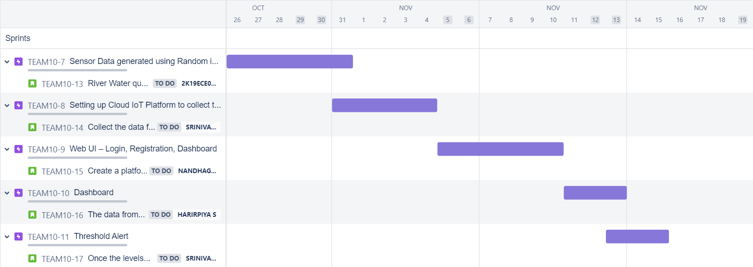

**Burndown Chart:**

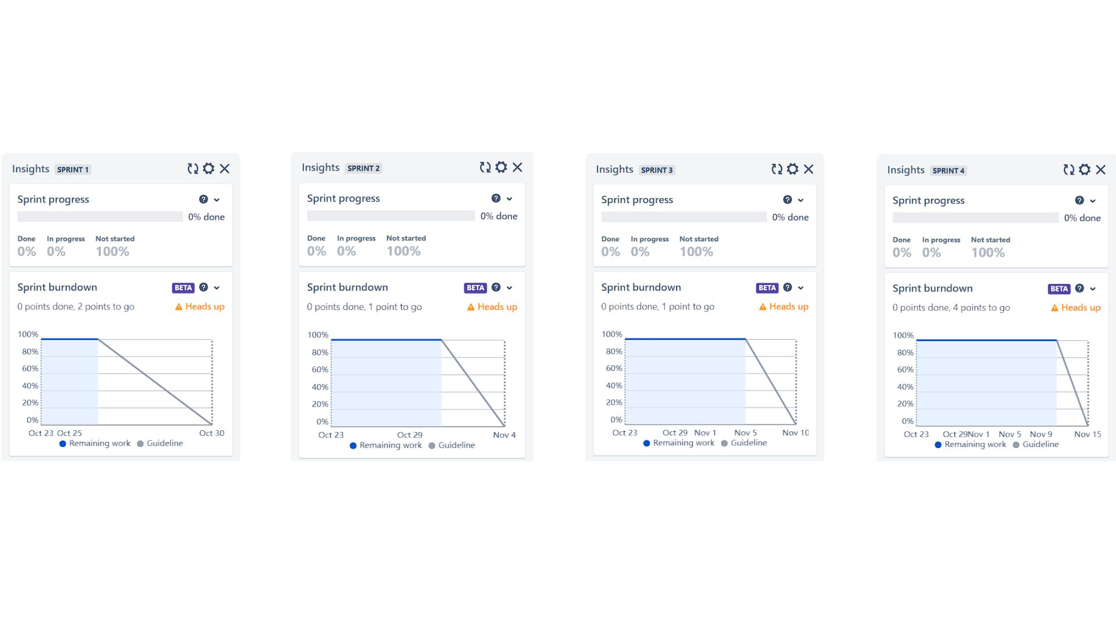

|  |  |  |  |  |  |
| --- | --- | --- | --- | --- | --- |
| Sprint 1  Dhinakar L |  | Sprint 2  Srinivas Krishna S K | Sprint 3  Nandhagopal Vignesh A |  | Sprint 4  Haripriya S |